Link to Interactive:
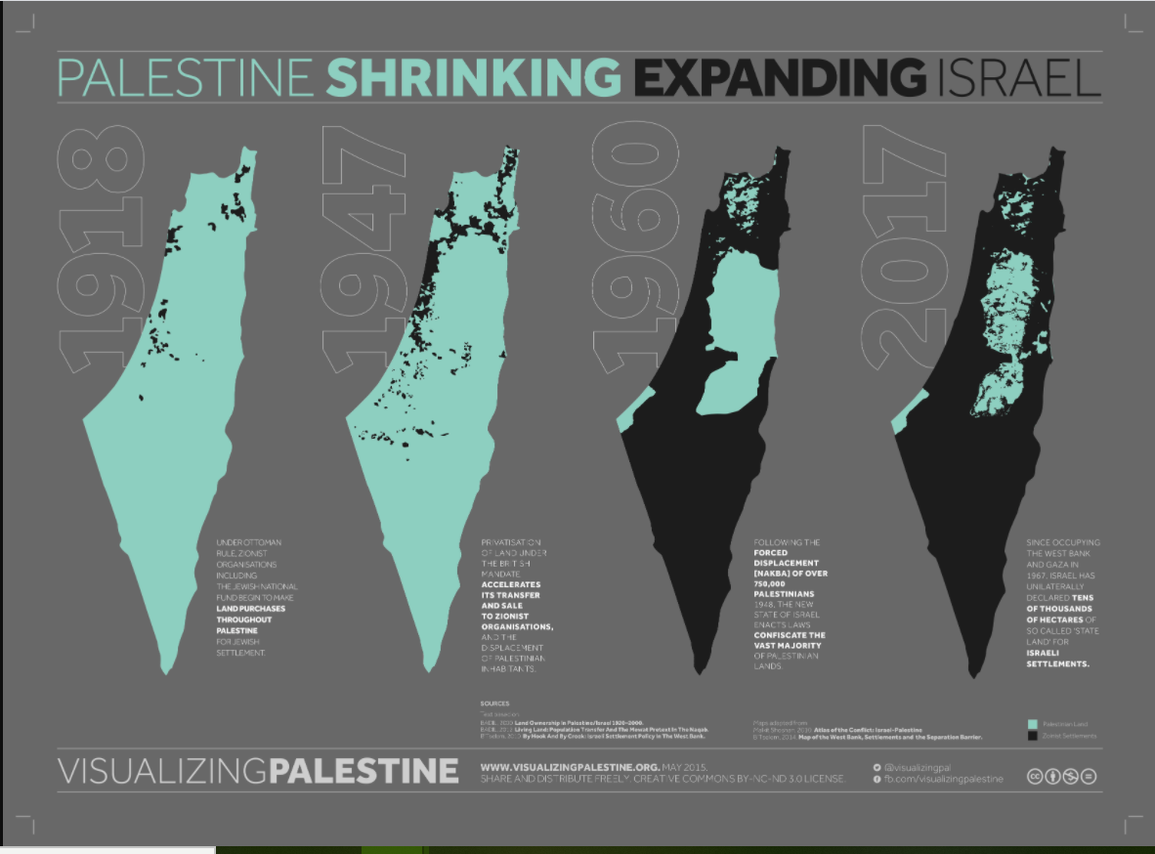
https://visualizingpalestine.org/visuals/shrinking-palestine/index.html

